**Project Title:**

Miniature Digital Flight data recorder (DFDR)

**Project Description:**

When building and creating small remote-control aircraft or drones, a mistake in the building phase or a malfunction of one or more modules can bring aircraft crashing down into the ground. What’s worse is not having a way of finding out what happened or what went wrong. To help investigators on real airline crashes, all commercial and some private aircraft are required to have a black box in their tail.

The flight data recorder is designed to survive crashes and records data such as GPS position, orientation of the aircraft and position of control and actuator surfaces. The main part of this project will consist of an ESP-32 board, GPS module, accelerometer and SD card modules to record the and save the data.

The complexity of this project for me would be getting the separate modules to send their respective data and display this data on the webpage as visual data and geolocating on a map to make it very easy to understand. This will be demonstrated in the field using a remote-control airplane to simulate and record data with the miniature DFRD attached.

**Parameters to be recorded**

Parameters that fit into the context of use and recording using a small remote-control airplane.

* Time.

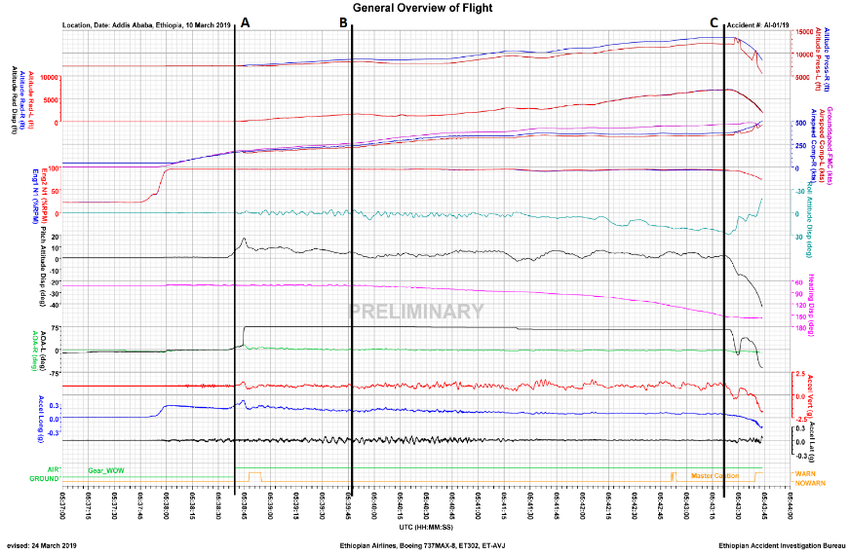

Graph of output parameters against time.

* Pressure Altitude
* GPS speed
* Normal Acceleration
* Compass Heading
* Motor Power
* Temperature

**Data Output and Proposed Graphical Display**

Typical Instrument panel of a small private aircraft, showing airspeed, artificial horizon, altitude, turn and slip indicator, Compass heading, and vertical speed

I hope to use gauges on the webpage to recreate something similar to display real-time data when communicating with the ESP-32

**Architecture Diagram**

**Timeline for deliverables**

Original Timetable

|  |  |
| --- | --- |
| 30 October | Proposal Completed and submitted |
| 13 November | Accelerometer sensor running |
| 27 November | GPS module running |
| 11 December | SD Card module running |
| 25 December | Testing system |
| 29 January | Wi-Fi module and web page |
| 12 February | Webpage created |
| 26 February | Using the cloud |
| 12 March | Testing all modules |

**Software programming languages to be used:**

C, HTML

**Hardware requirements if applicable:**

* ESP-32,
* GPS module,
* Accelerometer module,
* Magnetometer module,
* Gyroscope module,
* Barometric sensor module,
* SD card module,
* battery pack.
* RC Quadcopter.